ASA NEWSLETTER
April 2022
ASA SLOGAN: WE LOOK AT THE ABILITY NOT THE DISABILITY

ASA has made an excellent start to 2022, a year for which we have many plans and ambitions to support even more children with disabilities and their communities. In this newsletter we will provide an update of our recent activities and the plans for 2022.

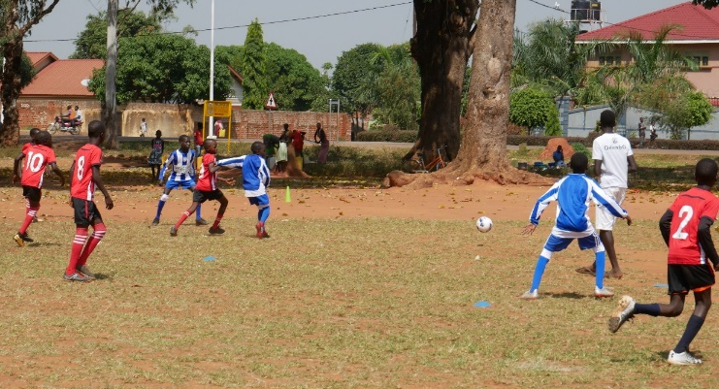
The ASA Junior Premier league 2022
This is one of best initiative of 2022 Introduced by ASA in February 15 2022 , the league aims at giving inclusive sporting platform for competition in the region. It follows from the famous Kids League of 2006, which only focused in football for boys only. After sixteen years we excited to have introduced more gender sensitive league catering for four different games that is football for boys and girls, Netball, and wheelchair Basketball. The league has registered 300 (180 males, 120 female) children with and without disabilities. We want to sustain this league and this cannot be done with your support and partnerships to support our children with; uniforms, playing boots, sanitary pads for girls, officiating fees, snacks and water for the different teams.
Team preparation for common wealth games in UK
ASA, through local community support raised $310 to facilitate 6 athletes to go for qualification trials and classifications in Kampala, in preparation for the Commonwealth Para Games in Birmingham UK. One of the athletes, Ochira Richard, a wheelchair racer, was selected to go for a training camp in South Africa and later participate in the world games in the UK. We are grateful to all our coaches and players for the great milestone achieved so far.

NEWS: ASA Kicked off engagement of training in 6 primary schools in Gulu
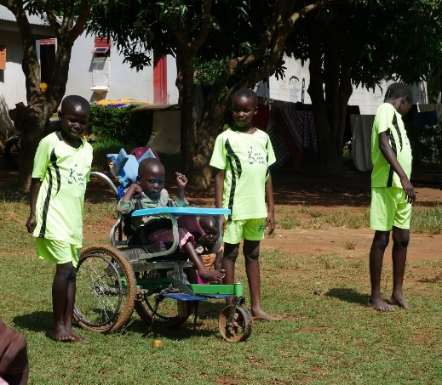
ASA works in 6 inclusive primary schools within Gulu City to engage over 230 children with visual impairment, physical disability, intellectual disability, hearing impairment and autism children in different adaptive sports to enhance their capacity, build their confidence and promote their social wellbeing in schools. The different engagement in adaptive sports and physical literacy it is supported through our supporters and the different schools we are working with.
Photo: Children with and without disabilities engaging in physical literacy every Monday and Wednesday from one partner school (Thumps up academy)

Highlights from 2021

The outbreak of Covid-19 in 2020 was a big challenge for ASA as a young community based organization we really struggled in the first five months of the pandemic. Being a sports organization all our activities were suspended due to the government preventive lockdown measures. In addition, there was fear everywhere among our beneficiaries and community at large, businesses were closed, and life became so hard for ASA’s passionate volunteers.

The future of the organization was in a balance no funding opportunities which impacted on the organization bills such as rents, administrative cost and stipends for volunteers.

Bouncing back from Covid-19
We would like to thank the Board of Directors of ASA, especially Amy Gillespie, for supporting the team in Uganda throughout the Covid-19 pandemic, it was not easy for our young organization to strive through to reach our beneficiaries during the lockdown but all was possible through the great commitment and passion from our team of volunteers. Below are some of the activities ASA managed to undertaken during the covid-19 pandemic.

ASA trained 40 teachers from 20 Primary School in rural Districts of Amuru and Gulu on Adaptive Sports and Inclusive physical education.

ASA was contracted by Save the children Uganda in their project of Together for Inclusion (TOFI) to train 40 schoolteachers from 20 primary schools in Amuru and Gulu District on Inclusive Adaptive Games and Sports. The aim of the training was to increase knowledge and skills of teachers on how to include learners with disabilities in different games and sports activities. This has resulted in an increased number of children with disabilities engaging in sports, and participating in school.

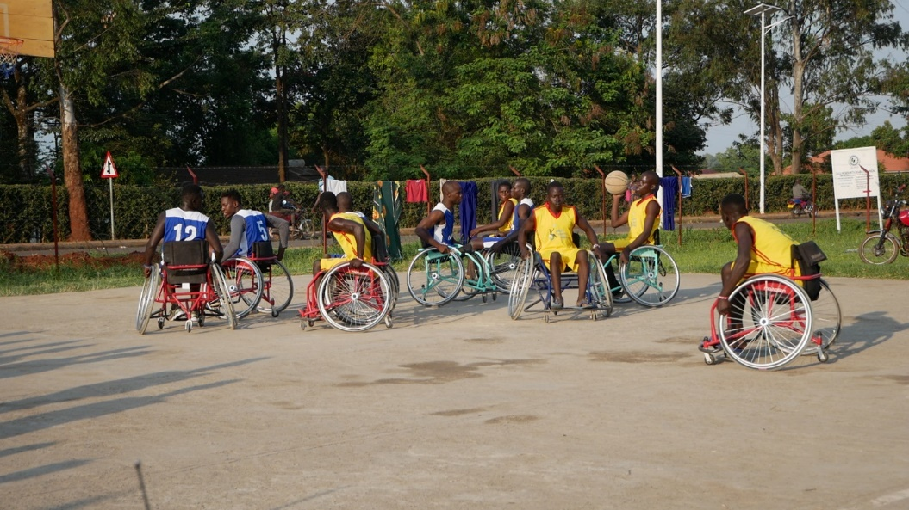
Photo: Adaptive sports Sit Volleyball training on going for teachers (coaches) at Patiko Prison from the different schools.
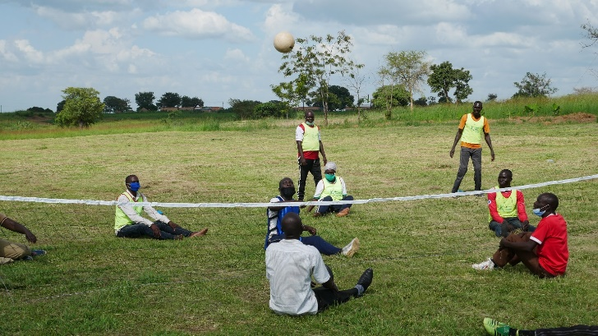
Case Study
Ismail is the Game and Sports teachers at Pawel Angany Primary School in Amuru District in Northern Uganda, this is what he said, “before i got training in Adaptive Sports and Inclusive games, it was really hard for me to inclusively engage learners with disabilities in my sporting program at school, i admit that lack of knowledge greatly contributed to segregation and exclusion of learners with disabilities in school, many children with disabilities lives inactive lifestyles, they usually fail to socialize with others, and when it comes to Physical Education (PE) time there work is to take care of their colleagues belongings, we thought this practice was normal to every child with disability but after the training we realized that we were not inclusive and we did not meet the needs of the children instead we contributed to exclusion of these children with disabilities. When we introduced adaptive games at our school we realized and witnessed increased involvement of children with disabilities in different activities, we witnessed a number of them taking leadership roles to initiate activities, now they don’t take care of their colleague’s properties they are actively involved. Due to the different games and equipment’s we have witnessed increased enrollment of children with disabilities in schools.”

New partnership with organizations in 2021

Ability Sports Africa entered into a working agreement with two organizations (Gulu TEAM initiative and Rhino Athletic Club) in the year 2021, to help support our vision of an inclusive community for all children and youth with and without disabilities in Uganda. ASA is currently working with Gulu Team Initiative, a local organization supporting digital inclusion in schools for learners, through the partnership our children with visual impairment at Gulu Primary school will receive 2 computers and JAWS (Job Access with Speech) to enhance their training on digital literacy. Secondly, and Rhino Athletic club is also one organization that works in mainstream sports that ASA started to work with in the year 2021. By working together, we aim to bring the component of inclusion to all mainstream games in Uganda. Thirdly, we are working with Backup Uganda to Support children with learning disability achieve out of classroom activities through games and sports to enhance their learning. Through the different partnerships we are able to run our activities, these collaborations provide material support, manpower and expertise to achieve our goal of an inclusive community in Uganda.

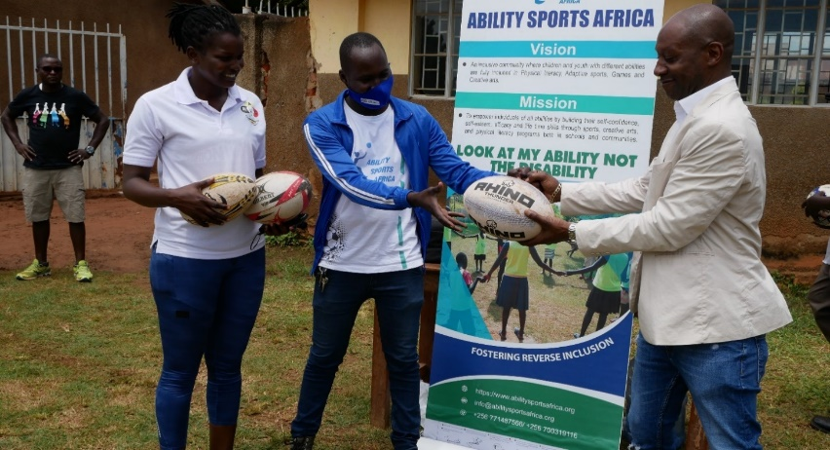
CEO ASA Musema Faruk second left in blue jacket near Akello Cissy Rhino Athletic Club Hub Coordinator Northern Uganda Sealing partnership agreement with CEO Gulu TEAM initiative

I-Big heart for humanity campaign 2021

During the second lock down in Uganda, the government planned food relief effort failed due to high demands and overwhelming numbers of vulnerable families, unfortunately persons with disabilities were left out of the program. In addition the second government effort of sending money to phones to vulnerable persons failed because most vulnerable families did not have phones and the registration process was a long hence leaving out many families without food.

ASA volunteers started home visits, the team realized that most of beneficiaries are starving, many children with disabilities became malnourished and weak. This was due to their parents losing their jobs, many families relocated to villages due high rents bills and increased costs of living in urban centers. ASA conducted an assessment and selected 40 of the most vulnerable families of parents with disabled children and youth within slum areas of Gulu City Council to be supported with food relief of (20kg Beans, 10 Kg Maize flour, 2litrs of cooking, 2 Bars of shop, 4 Packets of salt etc.). ASA being a nonprofit organization whose work is fully funded by donations from well-wishers and supporters, we created an online fundraising on Given Gain Online platform with a target of $1000, and also we mobilized for local community fundraising through YouTube based Gulu Site TV with support from Luo Comedy groups and lastly through ASA Board of Trustees Contributions.

The campaigned was named the Big Heart for Humanity, this campaign was the first successful activity done through our local and online fundraising were over 40 children and 15 youth with disabilities and their families members benefited from the Covid-19 food relief program. This support changed the mindset of parents for children with disabilities in the community because they realized that there are people who do care about their children and would love to secure a better future for their children with disabilities.

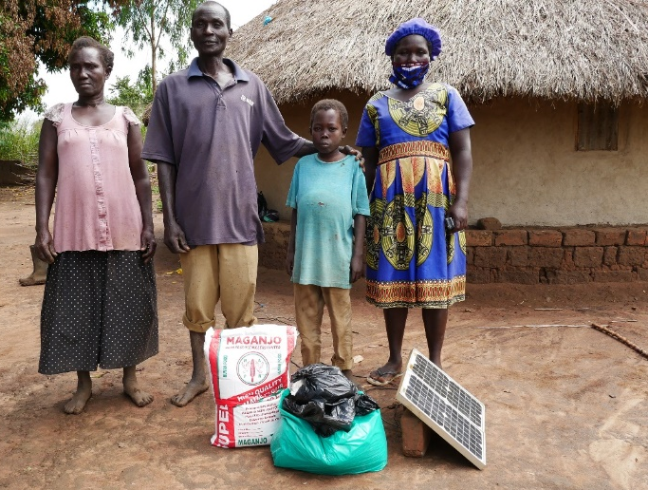
Photo: A family with a child with c sickle cell received their food relief in Gulu District Onyama Sub county (hard to reach areas)

Through this campaign we realized that 95% of children with disabilities come from the margins of society, whereby their parents cannot afford a proper meal in a day. The worst bit of it is that all these children live with single mothers, grandmothers and relatives, a woman who gives birth to a disabled child is considered cursed by the gods in Luo traditional believes, often they are chased away from their marriages and there are often cases of abandonment of disabled children by mothers and some even intentionally leave them to drown in wells, rivers and streams. A case registered last years (2021) in September 3 children with cerebral palsy were intentionally dropped in Aswa River by their mothers in Gulu District it’s really a pity

CASE: 1 Impact on Community.
Through the campaign ASA managed to complete a house for a single mother of two children. 5 years ago (2016) Mama Jonathan was a kindergarten teacher, she had a good life with her husband everything seems to move on well, when she got pregnant with her first child it was a big news to the young parents to be, she started going for maternity check-ups but in her last months of pregnancy she started feeling pain and abnormal reaction and the doctor requested her to go for operation. However, her husband refused to take in the doctor’s advice, and while in labor her delivery took so long which affected the child, due to a shortage of oxygen to the brain of the child he developed cerebral palsy. This was a bad new to the husband who changed his attitude negatively towards, accused her of being cursed by the gods, and insisted that disability is not welcome. Mama Jonathan was abused, beaten, and insulted for giving birth to a disabled child. The father stopped providing money for food, life became so hard for her and Jonathan. The husband later brought in another wife in the same single room eventually Mama Jonathan was chased out of the house, two months later she realized that she is 2 months pregnant with the man who denied her because of giving birth to a disabled child she started taking care of the two children in a rented place in slum areas of Gulu City. On top of this, during the Covid-19 pandemic she became homeless.,
ASA initiated a fundraising campaign, including local fundraising within Uganda and outside Uganda from friends and friends of friends. With this support we managed to get land outside Gulu City for Mama Jonathan, and managed to build a two room mud house for her. Mama Jonathan is very happy and grateful to the board of ASA and the team of volunteers for changing her life.

There are many single mothers in Gulu Northern who needs different types of support from school fees, feeding, clothing, medication and assistive devices for their children.

To support them or be part of ASA donor/ fundraising support please contact us @ info@abilitysportsafrica.org

Photo: Mama Jonathan in her new home
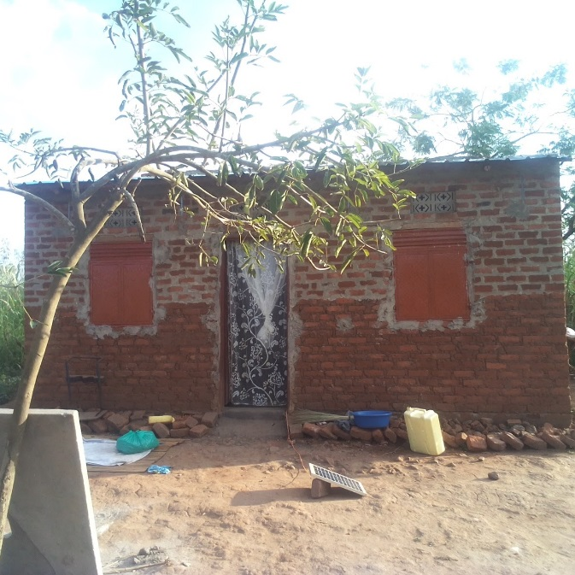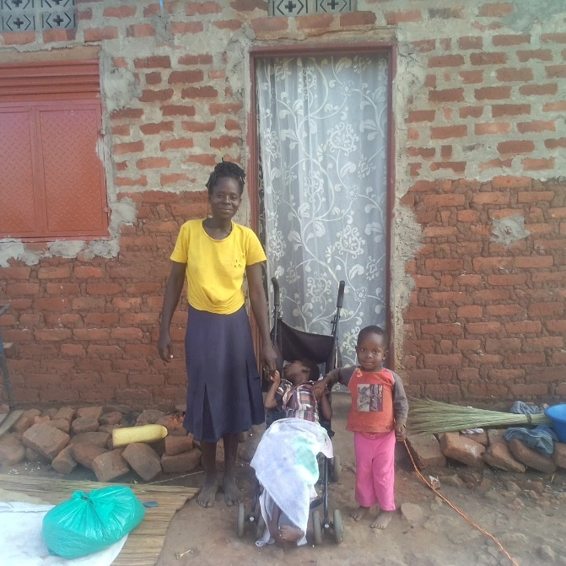
Here are the links to our you-tube videos on the activities done
https://youtu.be/yxf51g-cC2k
https://youtu.be/EerJ5WgLprI
https://youtu.be/ddPCiI4PYQw
https://youtu.be/5cK7ezk91DA

October 11-16 Oct 2021
#Deaf football Challenge Cup. #FootballPeople weeks (Fare network)
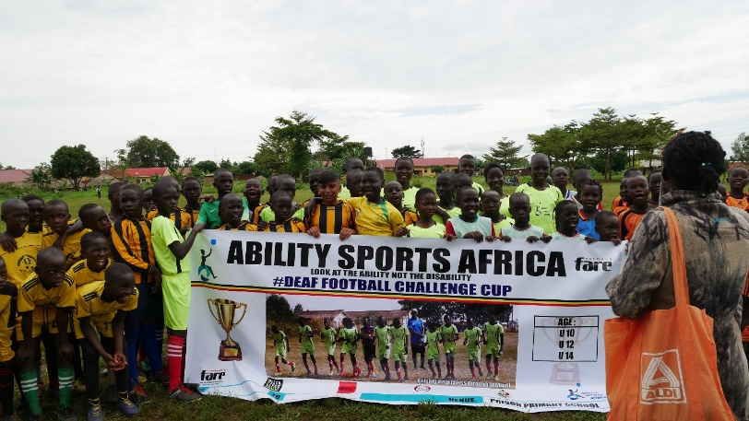

Photo: A total of 266 children (boys and girls) registered from different community teams, of which46 were children with disabilities.

The year 2021 Deaf challenge Cup was hosted by Omoro District Local Government in Northern Uganda with funding support from Fare Network UK to celebrate the global #FootballPeople week’s events on the 11-16 Oct 2021, it’s a tradition for ASA to organize at least one challenge cup aimed at raising awareness on disability. This year theme was about changing the negative attitude of the community towards hearing impaired children.

We engaged children with hearing impairment in a mixed team football competition with their hearing counter parts, this event created a big platform for awareness creation, attitude change, mindset shift, social inclusion, advocacy and a big boost for physical and mental health development through the games played
November 9 2021
Finalist at the Dot Org Impact Award (.org impact awards 2021)
ASA made it as The 2021 .ORG Impact Awards finalists in the categories of Championing Diversity, Equity, and Inclusion, we are recognized amongst remarkable group of mission-driven organizations from around the world, devoted to meeting society’s most pressing needs.
In total, 633 organizations and individuals submitted entries from more than 40 countries. Submissions were reviewed and scored by a panel of judges who are leaders in the internet, non-profit, health, education, and marketing sectors. All nominations were tied to an active website with a .ORG domain.
We are very proud of this milestone reached by the grass root organization like ASA. Here is the link to the you tube video and web page.
https://orgimpactawards.org/2021-org-impact-awards-finalists-named/
https://youtu.be/2RYwavpDK6c

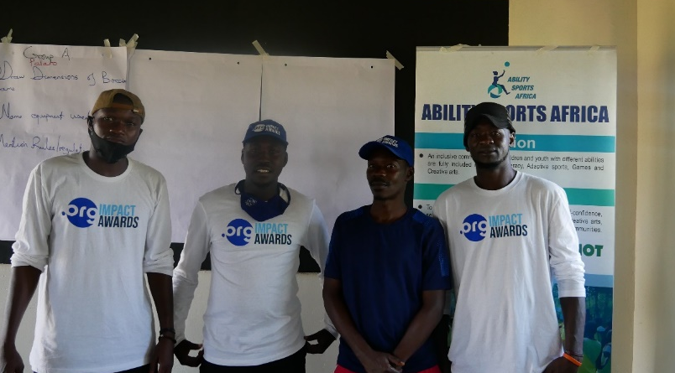
Photo: ASA coaches during refresher training for teachers from 20 schools in Gulu & Amuru

23 DEC 2021
Christmas Party for Children with disabilities in Gulu Uganda.
In a special way we would like to thank our supporter Selma Scheewe and our Board of Directors Babu Manya, Joe Nyero, and Amy Gillespie for making the party a reality. The 2021 Christmas Party was the first ever Party organized for children with disabilities in Gulu Northern Uganda, this was made possible through our online fundraising, supports from friends and one off donors which we managed to raise $1250 of $2500 target, we want to thank all our supporters, friends and the Board of Directors of ASA for making a big difference in the lives of our CWDs and their families. Through this support a total of 30 children had fun, played different adaptive games, fun games, like treasure hunting, planting and harvesting games, music and dance, children received T-shirts, enjoyed drinks and snacks, on top of that 25 school going children received scholastic materials like Dozens of Books, Pens, Pencils, Mathematical sets, bags and food relief to all the parents who attended the function to celebrate with Christmas and New year.
Here is the link to the Coverage of the event.
https://youtu.be/gBfHbszdI_
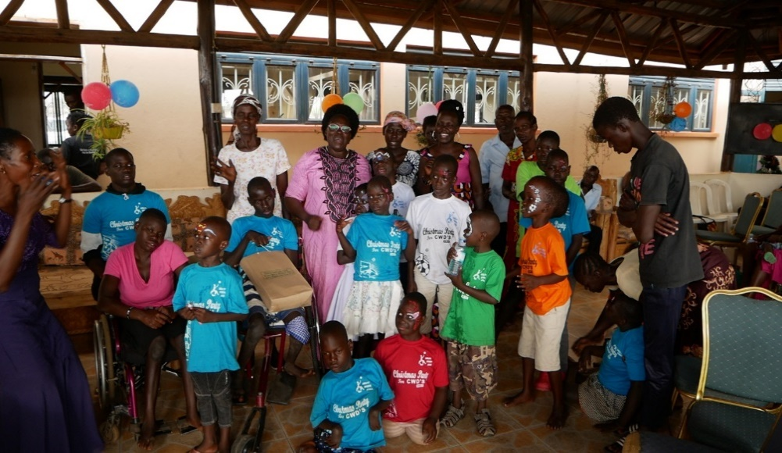
Photo: Children with disability with woman member of parliament Betty Aol Ochan in Pink

We still have very many teachers (400) in the region who need this kind of training you can support us with equipment like adaptive equipment’s like goal ball, Boccia balls, showdown board, table tennis and equipment’s or even become a monthly donor to support our trainers cost.

For more information about ASA
Please contact us on
Email: info@abilitysportsafrica.org
Website: https://abilitysportsafrica.org
Contact us on phone: +256771487566 +256700319116

To support us please donate to through our Given gain account on the website or
BANK DETAILS BELOW
Account Name: ABILITY SPORTS AFRICA
Account Number: 2291474529
KCB SWIFT CODE: KCBLUGKA

